**Project ID :** 4

**Project Title :** Single Image Layer Separation using Relative Smoothness

**Git Hub Link :** <https://github.com/nsmadan-pgssp/DIP_PROJECT_TEAM4>

https://github.com/nsmadan-pgssp/DIP_PROJECT_TEAM4

**Team Members :**

* Madan NS – (2018900075 - [madan.nandiwada@students.iiit.ac.in](mailto:madan.nandiwada@students.iiit.ac.in) )

**Team Mentor/TA Assigned :** Karandeep Singh Juneja (karandeepsingh.juneja@students.iiit.ac.in)

**Main Objective of the project :**

Two-layer extraction from an image.

**Problem definition (What is the problem? How things will be done ?)**

Problem :

There are two problems which will be worked on this project

1. Intrinsic image decomposition: Decomposing the images in Decomposing the image into different components like shade, reflectance and shape.

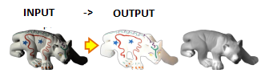

1. Reflection interference removal - Reflection interference arises when a photo of a scene is taken

behind a glass window or any colourless sheet.

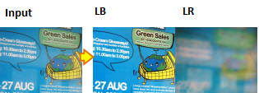

Input - input image.

LB – Background Part

LR – Reflective part

How things will be done :

* Checking different papers for image extraction as part of literature survey.
* Check the Intrinsic image decomposition and Reflection interference removal algorithms as a part of literature survey.
* Detailed study of the gradient sparsity prior method as it is mentioned in the paper.
* Optimization of the algorithm to be used in project.

**Results of the project :**

Python based Program – which can take an image as input and show the extracted layers of the image.

**Project Milestone and expected timeline :**

* Weekending 11th October 2019 – Completion of Literature survey.
* Weekending 18th October 2019 – Finalizing image decomposition and reflection removal algorithms. Checking for optimization.
* Weekending 1st November 2019 – Completion of Phase 1 of the code and first code review
* Weekending 08th November 2019 – Completion of code review comments and tuning.
* Weekending 24th November 2019 – Report, Presentation and observation notes creation